Build and Deploy Resume Analyzer with OpenAI and Azure

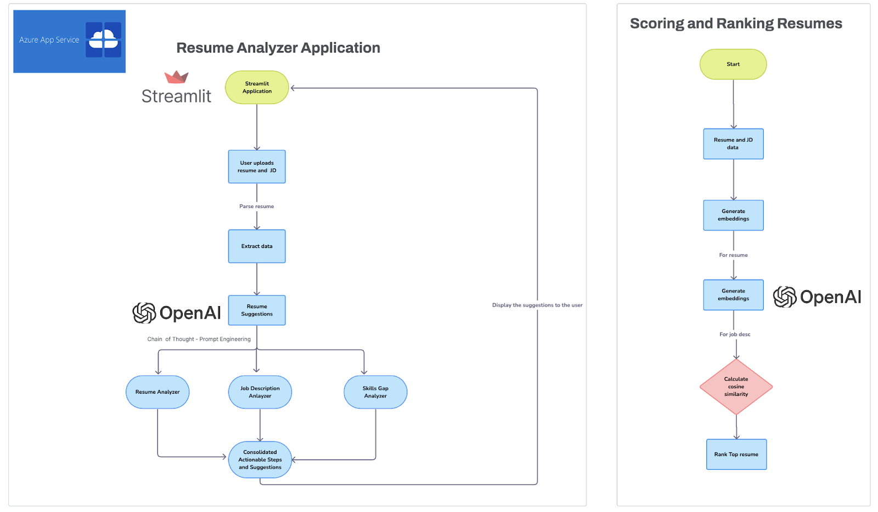
Project Overview
In today's competitive job market, candidates often struggle to understand how well their resumes align with job descriptions. Traditional resume screening systems rely heavily on keyword matching, which can overlook context, skills, and experience relevance.
This project develops an AI-powered Resume Analyzer that leverages OpenAI GPT-4, OpenAI Embeddings, LangChain, and Azure to provide intelligent resume evaluation. The solution compares resumes against job descriptions using semantic embeddings and cosine similarity, identifies skill gaps, and generates personalized improvement recommendations.
The application enables job seekers to proactively optimize their resumes and improve their chances of success in job applications.
Prerequisites
- Basics of LLMs
- Vector Databases
- Prompt Engineering
- Python
- Streamlit
Aim
Develop and deploy an AI-powered Resume Analyzer that evaluates resume-job description alignment, identifies missing skills, and provides personalized recommendations to improve job prospects.
Data Description
Input Data:
- Job Descriptions (PDF/Text)
- Candidate Resumes (PDF/Image)
Output:
- Resume Match Score
- Gap Analysis
- Personalized Suggestions
- Resume Improvement Recommendations
Tech Stack
Language:
- Python 3.10
Libraries:
- LangChain
- LangChain-OpenAI
- Streamlit
- Tesseract OCR
Models:
- OpenAI Embeddings
- GPT-4
Cloud Platform:
- Microsoft Azure
- Azure App Service
- Azure Blob Storage
Approach
1. Data Parsing and Preparation
- Extract text from resumes and job descriptions
- Clean and standardize content
- Process PDF and image files
2. Embedding Generation
- Generate semantic embeddings
- Use OpenAI embedding models
- Capture contextual meaning
3. Similarity Calculation
- Calculate cosine similarity
- Compare resumes against job descriptions
- Rank candidates based on match scores
4. Gap Analysis
- Identify missing skills
- Analyze experience gaps
- Compare qualifications against requirements
5. Suggestions Generation
- Use GPT-4 to generate recommendations
- Suggest relevant skills
- Recommend action words and formatting improvements
6. User Interface Development
- Build Streamlit application
- Upload resumes and job descriptions
- Display scores and insights
7. Feedback Loop
- Capture user feedback
- Improve prompts and recommendations
8. Deployment
- Deploy using Azure App Service
- Enable scalable access
Project Structure
jd_data/
resume_data/
output/
├── jd_embeddings_large.pkl
└── resume_embeddings_large.pkl
src/
├── constants.py
├── directory_reader.py
├── embedding_model.py
├── resume_scorer.py
└── resume_suggestions.py
Resume_Scorer.ipynb
Resume_Suggestions.ipynb
requirements.txt
readme.md
File Description
directory_reader.py
- Reads and processes resume/job description files
embedding_model.py
- Generates semantic embeddings
resume_scorer.py
- Calculates similarity scores
resume_suggestions.py
- Generates improvement recommendations
Resume_Scorer.ipynb
- Resume matching experiments
Resume_Suggestions.ipynb
- GPT-powered recommendation analysis
Project Takeaways
1. Resume Screening Automation
2. OpenAI Embeddings
3. GPT-4 Integration
4. Semantic Search
5. Vector Embeddings
6. Cosine Similarity
7. Gap Analysis
8. Prompt Engineering
9. LangChain Framework
10. Resume Recommendation Systems
11. OCR-Based Document Processing
12. Streamlit Development
13. Azure Deployment
14. User Feedback Loops
15. AI-Powered Career Assistance
Business Benefits
- Improved resume quality
- Better job application success rates
- Automated resume evaluation
- Personalized career guidance
- Faster candidate assessment
- Scalable AI-powered career platform

